**LAB-02**

**DDL and DML Commands**

1. Questions 1:

(a) Create a Table

• Create a table named Students with the following fields:

StudentID (Primary Key), Name, Age, Class, Email.

(b) Alter a Table

• Add a column PhoneNumber to the Students table.

• Modify the data type of Age to TINYINT.

• Drop the column Email from the Students table.

(c ) Drop a Table

• Drop the Students table from the database.

(d ) Rename a Table

• Rename the Students table to StudentRecords.

SQL QUERY:

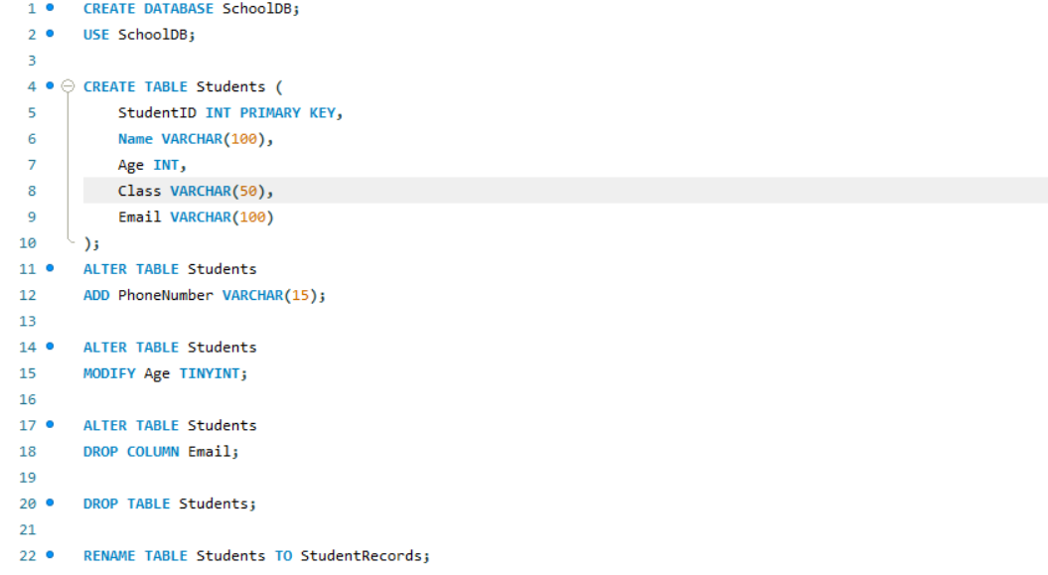

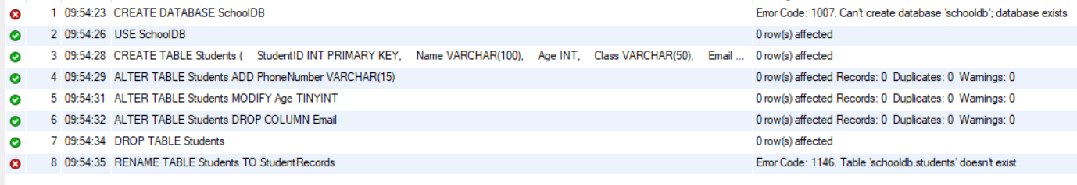

2. Question 2:

(a) Create a Table with Constraints

o Create a table named Courses with the following fields:

CourseID (Primary Key), CourseName (Unique), Credits (Default value 3),

InstructorID (Foreign Key referencing Instructors table).

(b) Check Constraint

o Create a table Employees with a check constraint to ensure the Salary is

greater than 5000.

(c) Unique Constraint

o Add a unique constraint on the Email column of the Employees table.

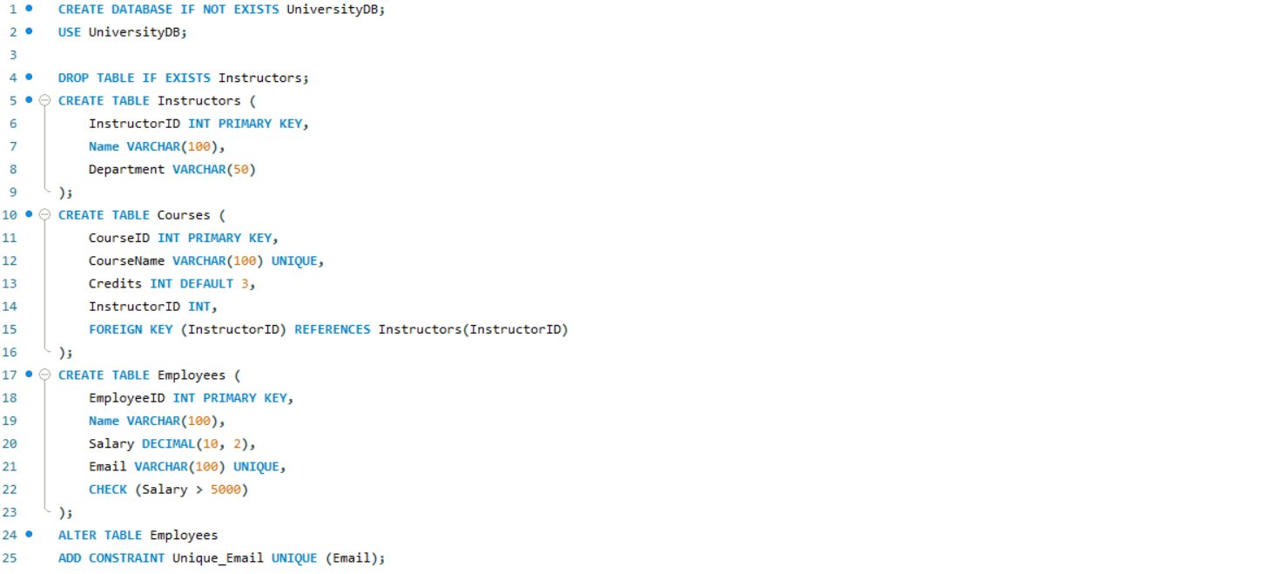

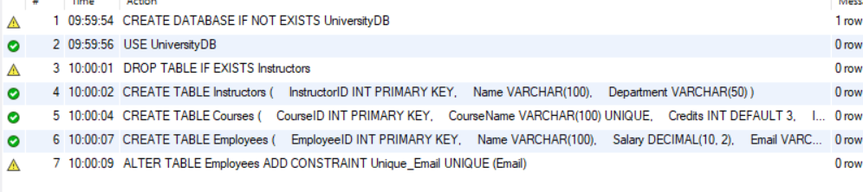

3. Question 3:

(a) Design and Create Tables for a Library Database

• Create tables Books, Members, and Transactions with appropriate fields and

relationships.

(b) Implement Referential Integrity

• Create a Department table and an Employee table.

Ensure referential integrity such that every Employee belongs to a valid Department.

(c) Create a Table with a Composite Primary Key

• Create a Marks table with a composite primary key on StudentID and SubjectCode.

(d) Perform DDL Statements for Migration

• Write DDL commands to copy the structure of a table OldData into a new table

NewData without copying its data.

